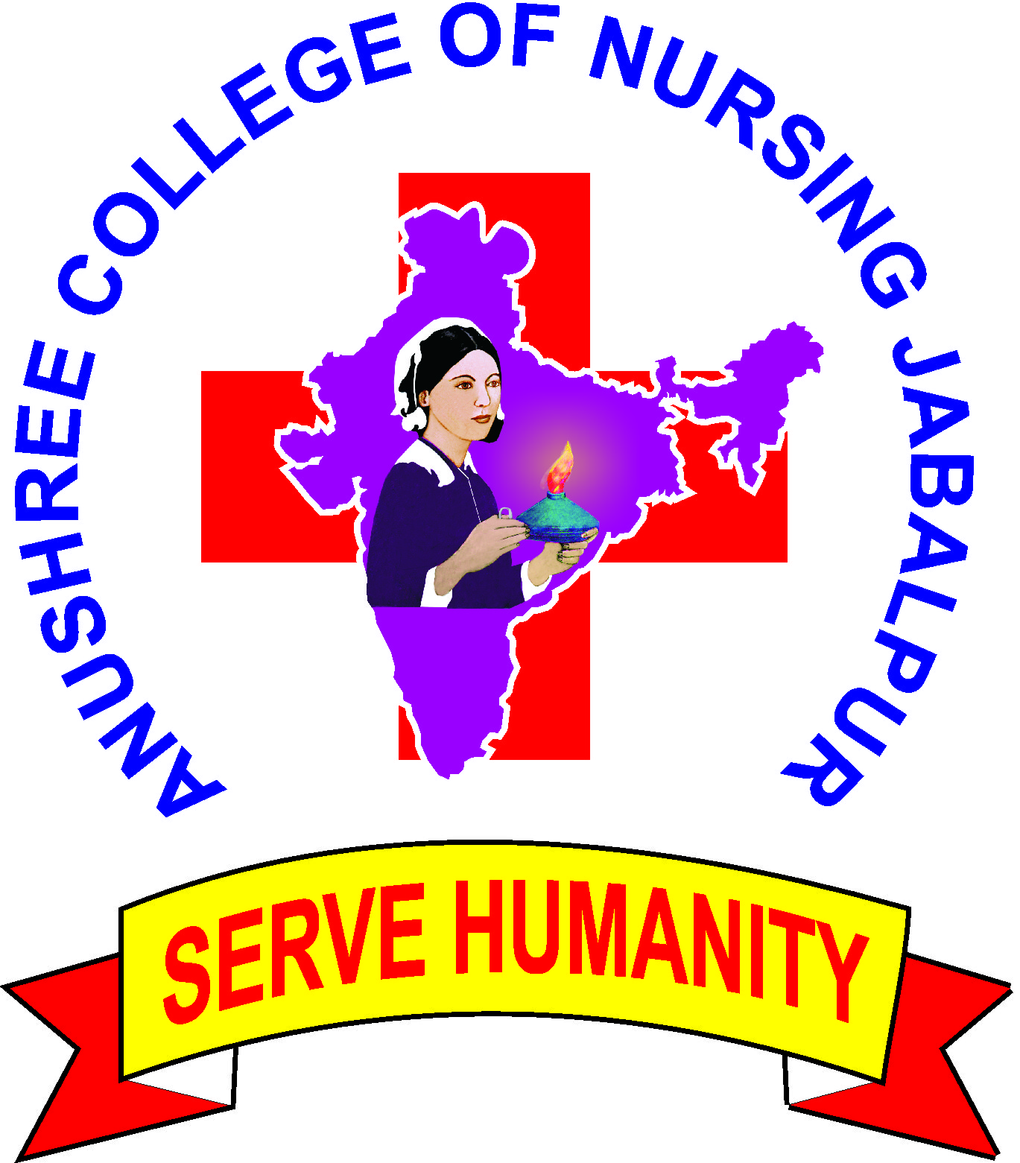ANUSHREE COLLEGE OF NURSING

Academic Calendar 2016-17
2016 October 1st - Commencement of Academic Session 2016-17
October first week - Orientation Week
October second week - Pooja Holidays(tentative)
October 10th - World Mental Health Day (Organize by B.Sc. 3rd Year)
October last week - Deepawali Holidays(tentative)
October 31 - Closing of Admission
November - Welcome Programme
December Second Week - First Internal Examination
December Third Week - Declaration of First Internal Exam Results
December last week - Winter Vacation
2017January 1st week - Lamp Lighting Ceremony
January 2nd week - Commencement Clinical Posting
January 26 - Republic day
February 4 - World Cancer day (Organize by M.Sc. 2nd Year)
March 3rd Week - 2nd Internal examination
March last week - Declaration of 2nd Internal Exam Results
March 24 - World TB Day (Organize by GNM 3rd Year)
April 07 - World health day (Organize by B.Sc. 2nd Year)
May 5 - World Asthma Day(Organize by GNM 2nd Year)
May 8 - World Thalassemia Day(Organize by M.Sc. 1st Year)
May 12 - International Nurses Day(Organize by B.Sc. 4th Year)
May Last week - Summer Vacation
June 14 - World blood donor day(Organize by B.Sc. 1st Year)
July 3rd week - Pre University Examination
July 4th week - Declaration of Pre University Exam Results
August 1st week - Commencement of Revision classes
August 15 - Independence day
August Last week - Farewell for outgoing batch
September 1st week - Preparatory holidays
September 2nd week - University exam (tentative)

ANUSHREE COLLEGE OF NURSING

Academic Calendar 2017-18
2017 October 1st - Commencement of Academic Session 2017-18
October first week - Orientation Week
October second week - Pooja Holidays(tentative)
October 10th - World Mental Health Day (Organize by B.Sc. 3rd Year)
October last week - Deepawali Holidays(tentative)
October 31 - Closing of Admission
November - Welcome Programme
December Second Week - First Internal Examination
December Third Week - Declaration of First Internal Exam Results
December last week - Winter Vacation
2018 January 1st week - Lamp Lighting Ceremony
January 2nd week - Commencement Clinical Posting
January 26 - Republic day
February 4 - World Cancer day (Organize by M.Sc. 2nd Year)
March 3rd Week - 2nd Internal examination
March last week - Declaration of 2nd Internal Exam Results
March 24 - World TB Day (Organize by GNM 3rd Year)
April 07 - World health day (Organize by B.Sc. 2nd Year)
May 5 - World Asthma Day(Organize by GNM 2nd Year)
May 8 - World Thalassemia Day(Organize by M.Sc. 1st Year)
May 12 - International Nurses Day(Organize by B.Sc. 4th Year)
May Last week - Summer Vacation
June 14 - World blood donor day(Organize by B.Sc. 1st Year)
July 3rd week - Pre University Examination
July 4th week - Declaration of Pre University Exam Results
August 1st week - Commencement of Revision classes
August 15 - Independence day
August Last week - Farewell for outgoing batch
September 1st week - Preparatory holidays
September 2nd week - University exam (tentative)

